Installing quartus software (Follow the snapshots and red squares!)
- At the time of creating this document the latest version of Quartus Prime Lite for a Windows operating system is 24.1
- Go to the link: https://www.intel.com/content/www/us/en/software-kit/849770/intel-quartus-prime-lite-edition-design-software-version-24-1-for-windows.html
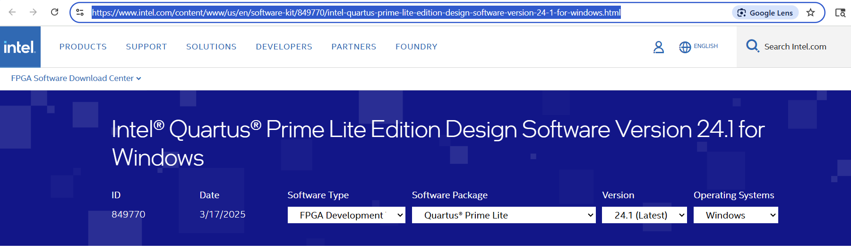
- Scroll down to ‘Downloads’ and download ‘Intel® Quartus® Prime Installer (Recommended)’
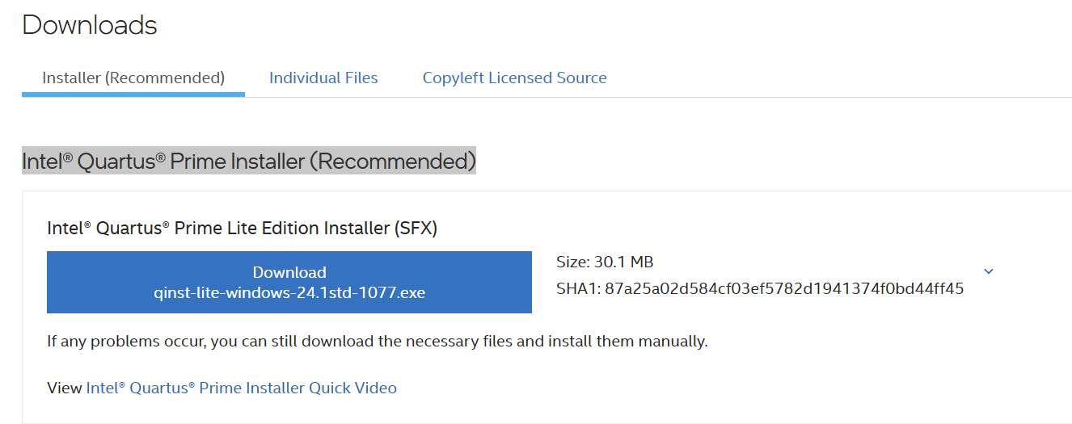
- Save this somewhere accessible. Now double click on the installer application (.exe) that you just downloaded.

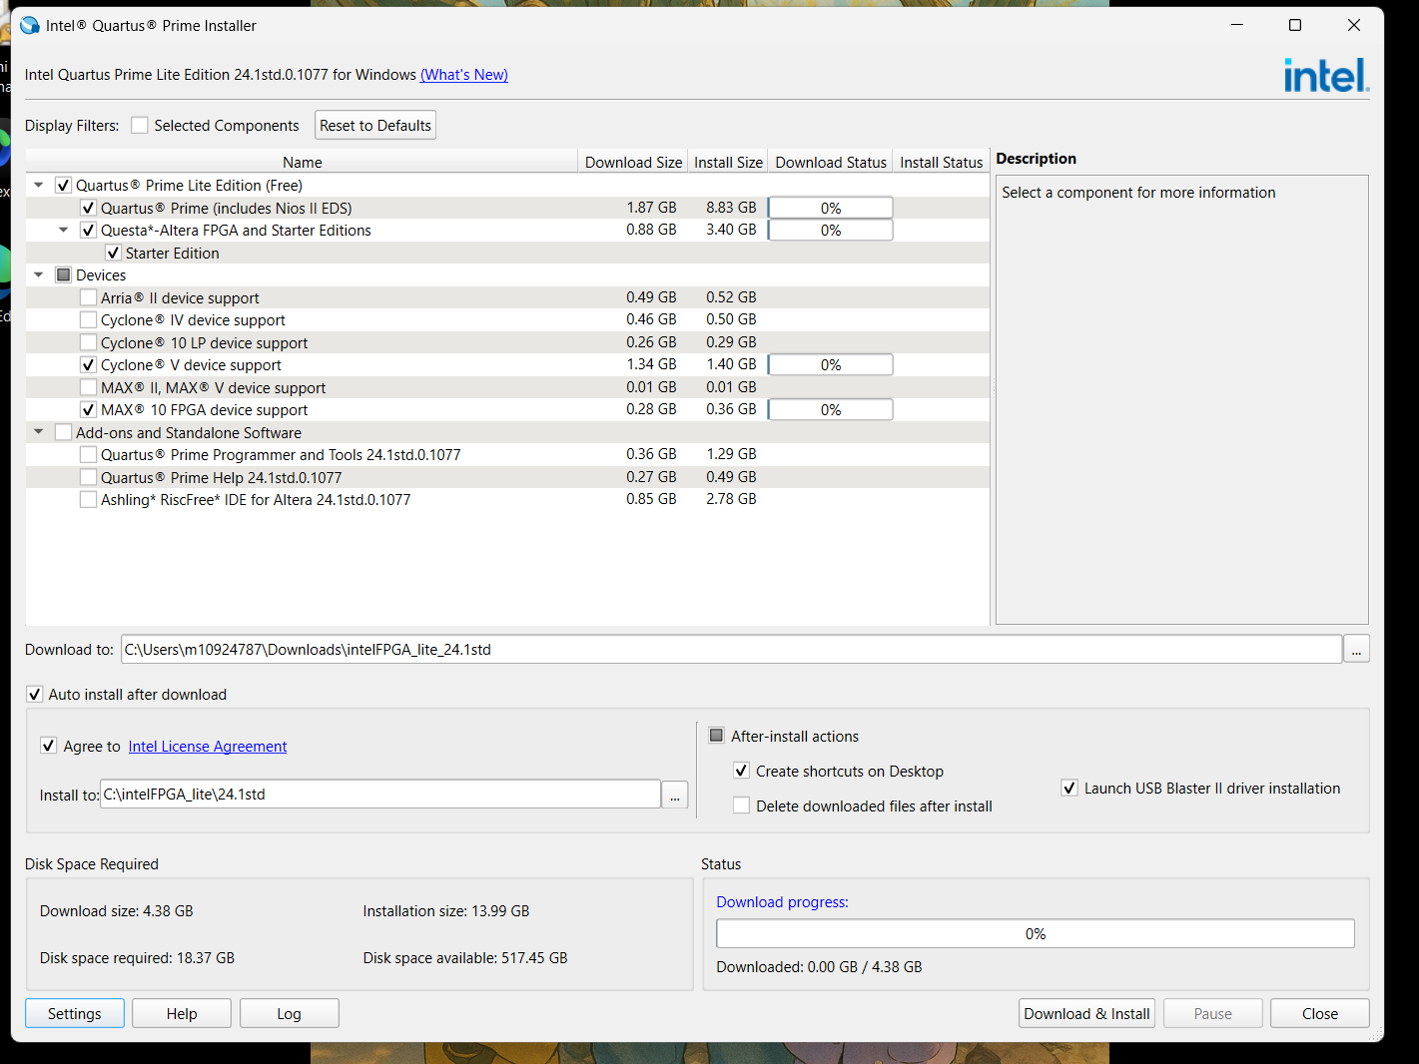
Get a cup of coffee and relax, it can take a while!

- Here is what you will see once the download and installation are complete (took ~44 min):
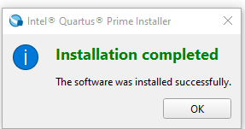
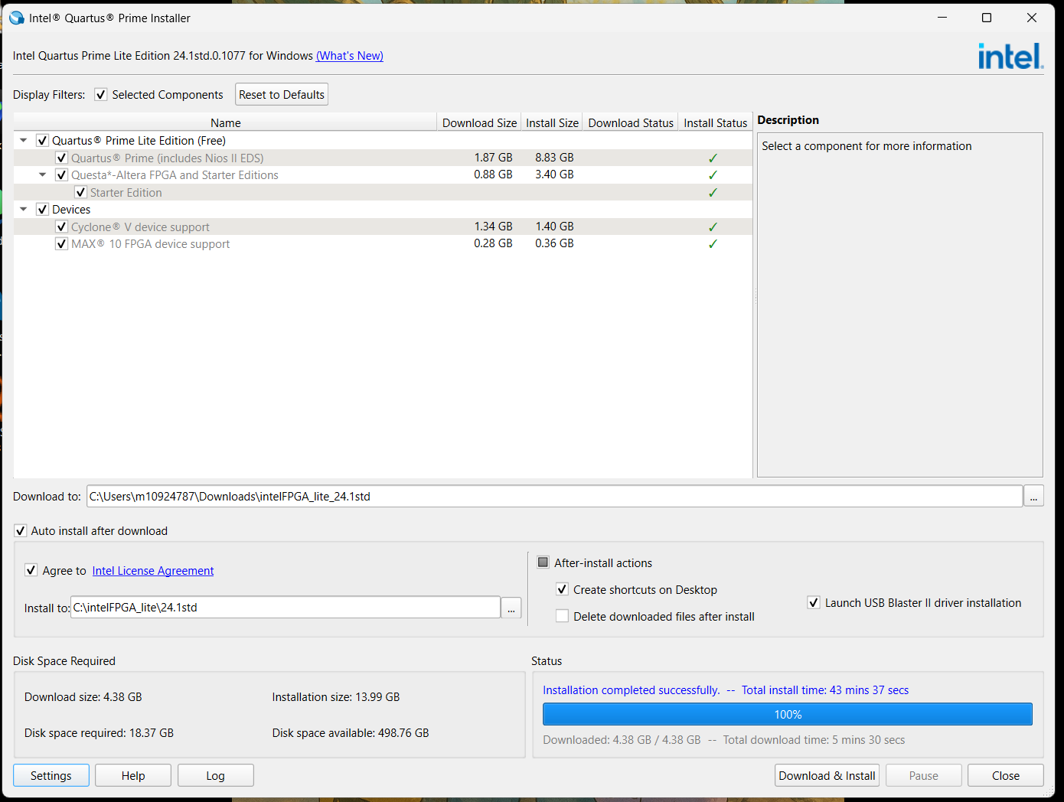

- The device driver installation wizard will launch automatically. Follow the snapshots and the red rectangles below!
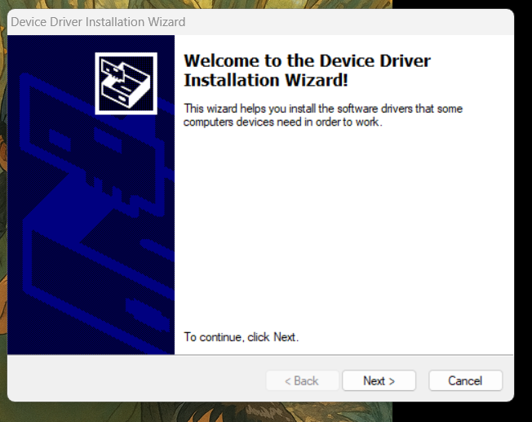

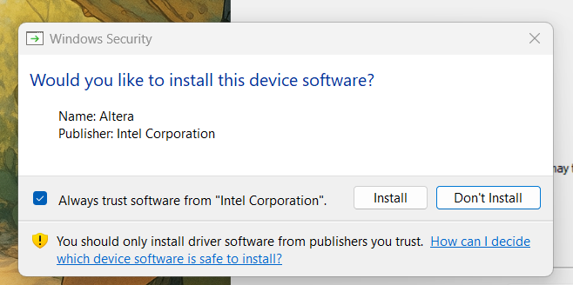
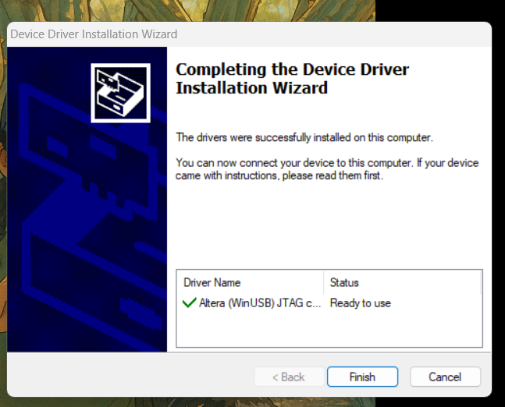
- We will use a simulator ‘Questa’ with quartus. Using this simulator requires us to get a (free) license from intel. The following steps will guide you through the process. Go to intel’s Self Service Licensing Center (SSLC) and click the link in Step 2: https://www.intel.com/content/www/us/en/support/programmable/licensing/support-center.html
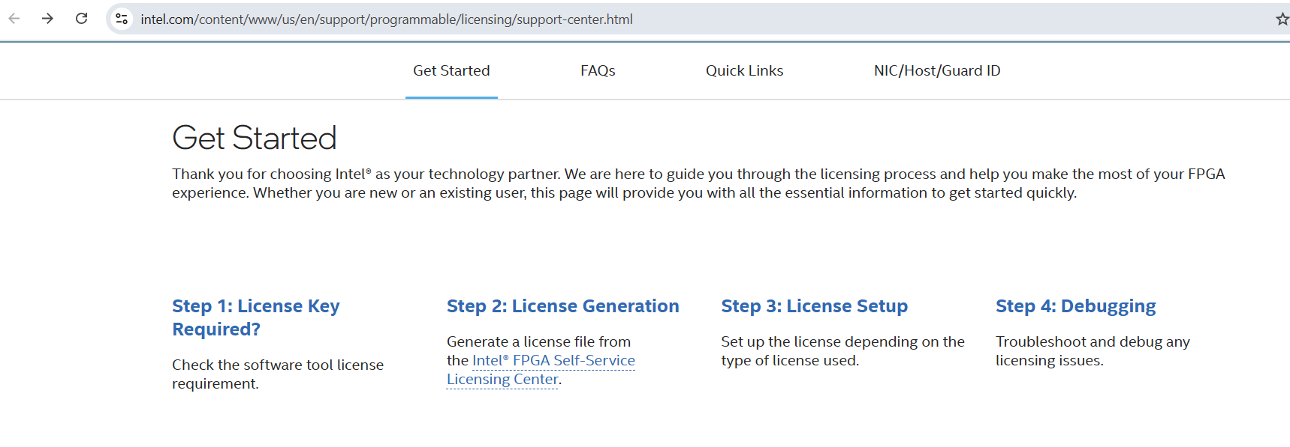
- If you have used intel’s SSLC before and have an account, simply login. If not, then enroll for the service. USE YOUR MINES EMAIL ID for this.
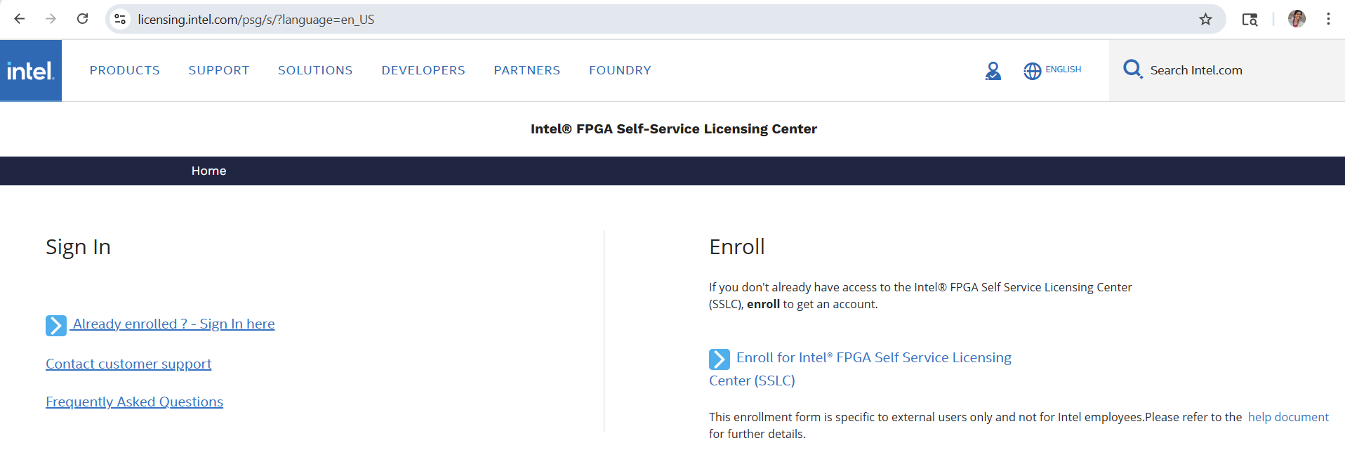
- Enter your email and fill out the details requested in the next step to verify your email. Enter the verification code sent to your email and ‘Create an account’
- Login to your account using ‘Sign in

- Click on ‘Sign up for Evaluation or No-Cost Licenses and choose Questa-FPGA Starter Edition (License: SW-QUESTA)
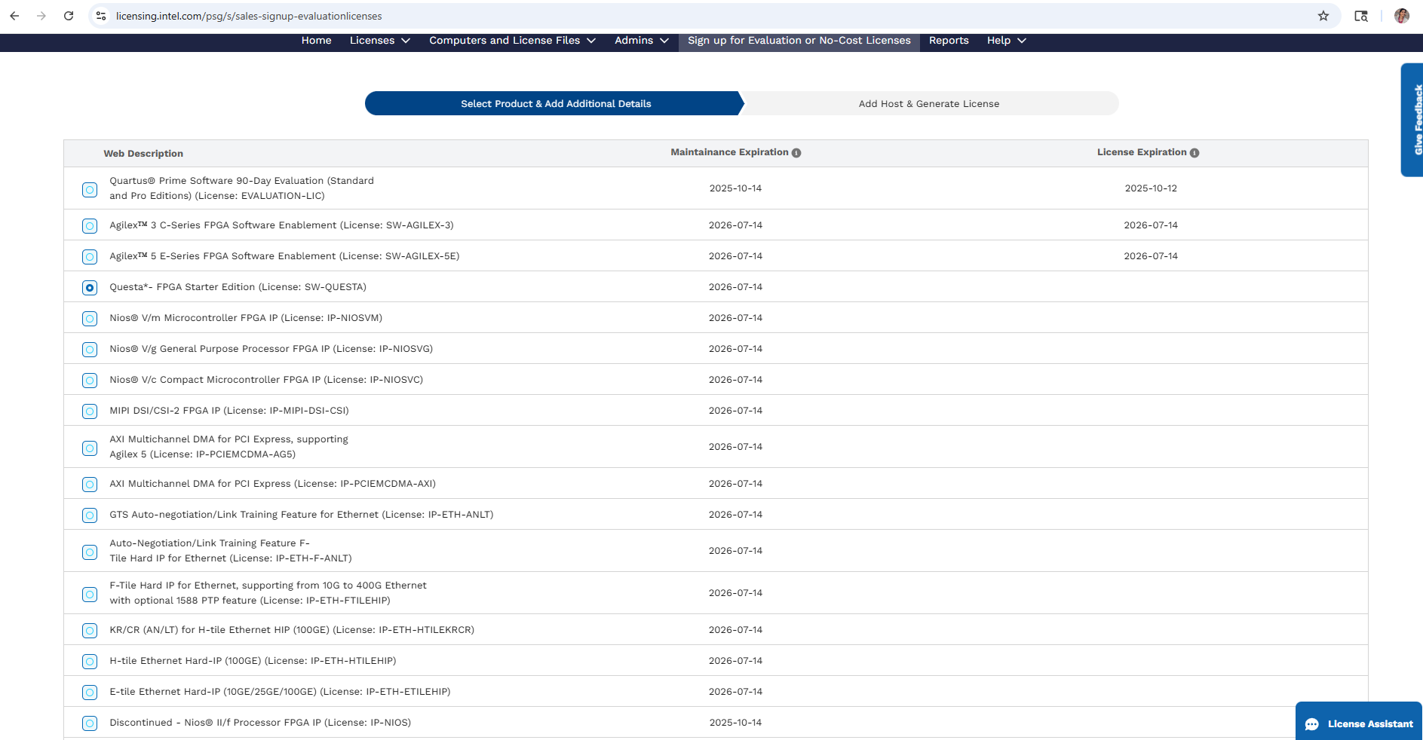

- On the next page, ‘Create a new computer’ and fill in information as below. Your Computer name should be your own name (or any other name you want to use).
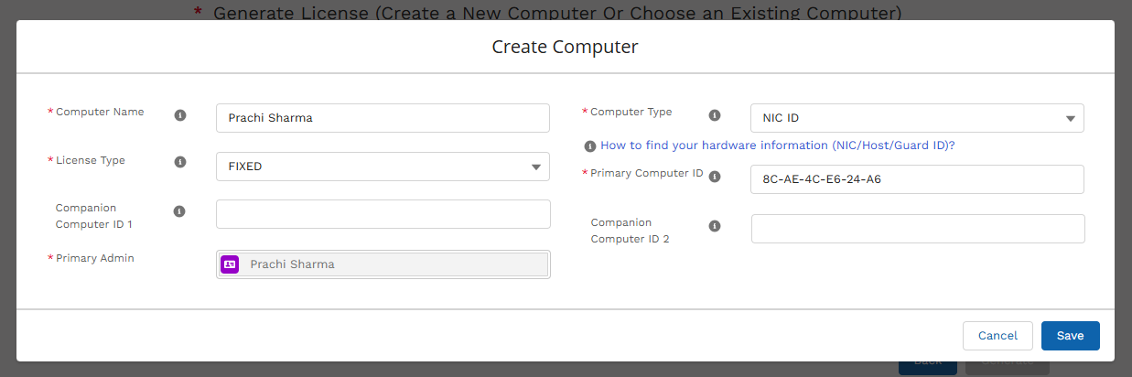
- To find the NIC ID, we need to use two methods. YOU MUST CHOOSE A NIC ID COMMON BETWEEN BOTH STEPS a. AND b.
  - Open the command prompt and type:
>ipconfig /all
You can see more than one result, pick one ‘Physical Address’. This is the NIC ID you will fill as Primary Computer ID. Don’t put a dash(-) between the alphabets/numbers of the Primary computer ID.
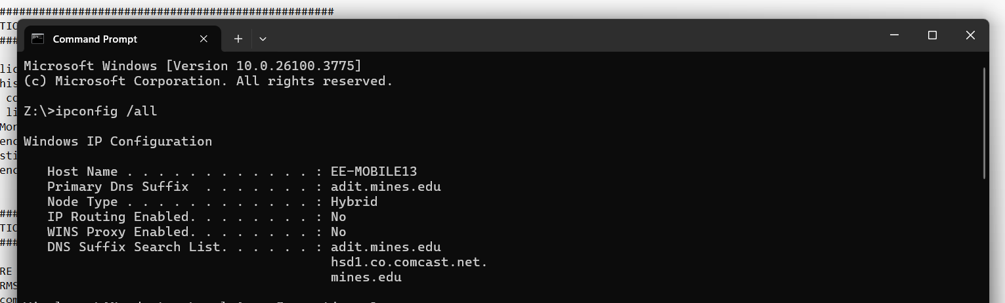
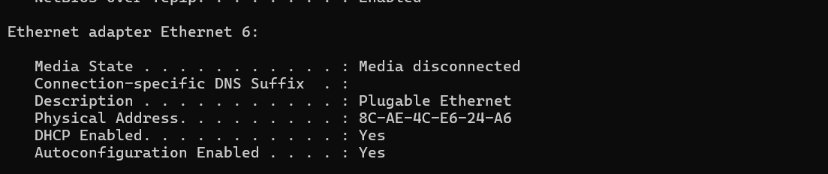

  - Launch Quartus. In the menu options in the toolbar at the top of the screen, choose ‘Options’ -> go to ‘License Setup’ and choose a NIC ID. Look at the screenshots below:
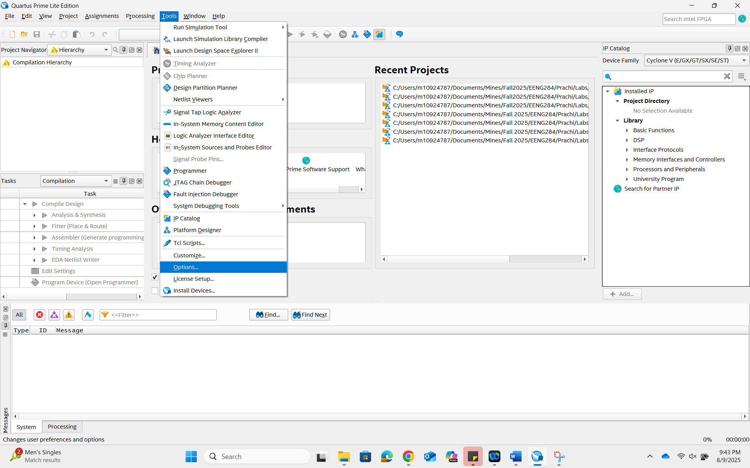

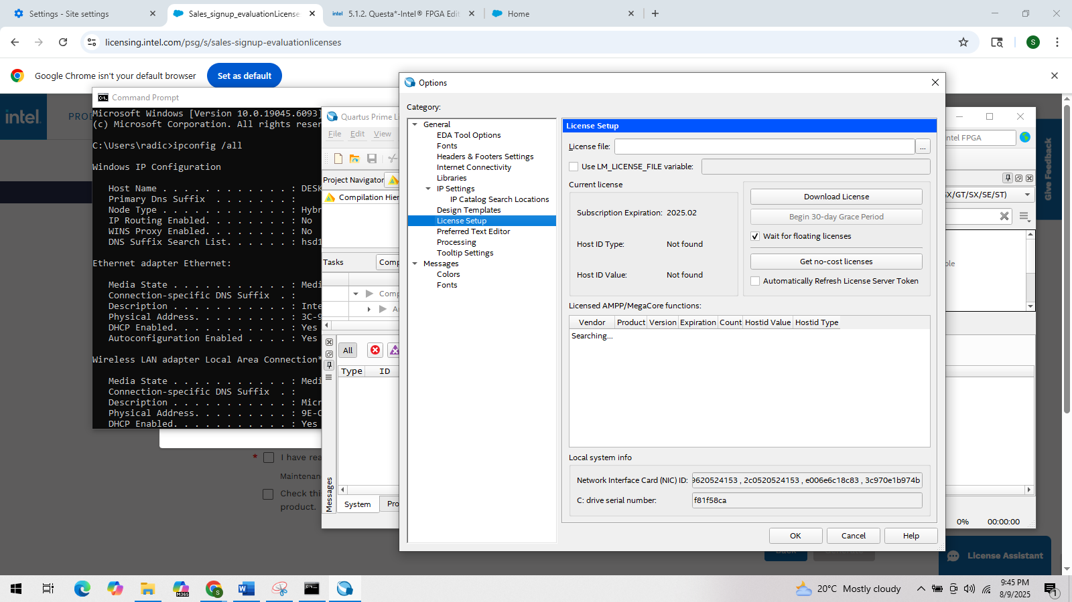

- Fill the NIC ID in step 12. Once you have filled out all the information requested in step 12, you will see the computer you added showing up to generate a license. Agree to the terms of use and click ‘Generate’.
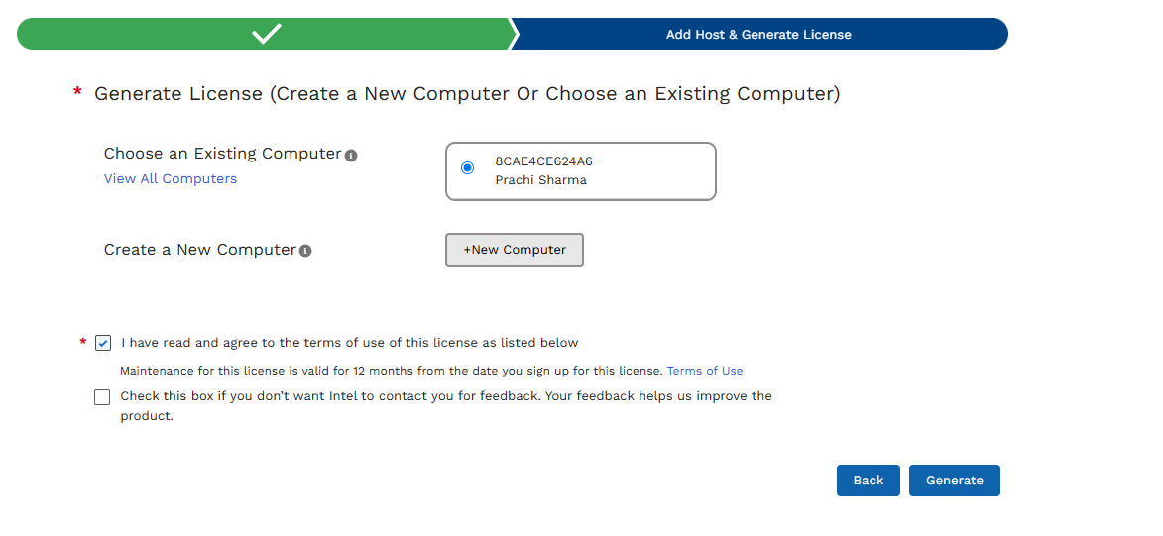
You should see the following screen. You will receive the license file on the email you used to enroll for SSLC.
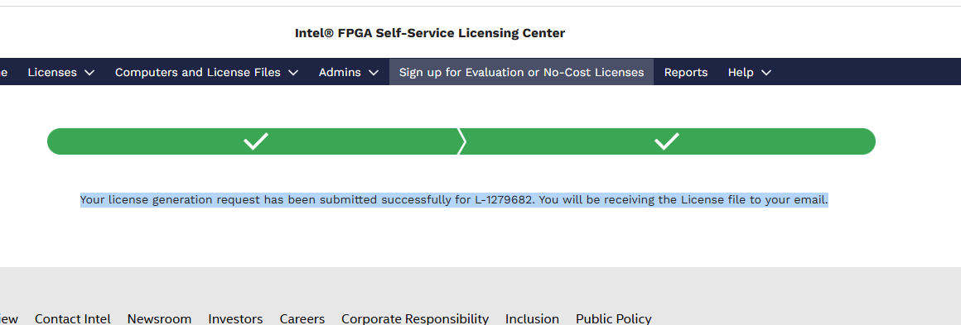

- After getting the license file from intel on email, save it in some location where you won’t delete it. I have saved in C:\intelFPGA_lite as LR-XXXXXX_License.dat
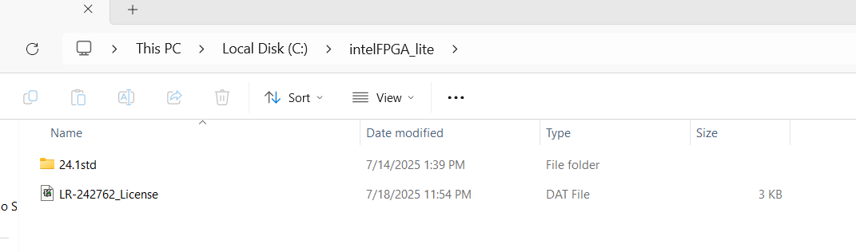
- Now we will add environment variable to access the license file. Click on the windows start button and go to - > Settings -> System -> Advanced system settings-> Environment Variables.
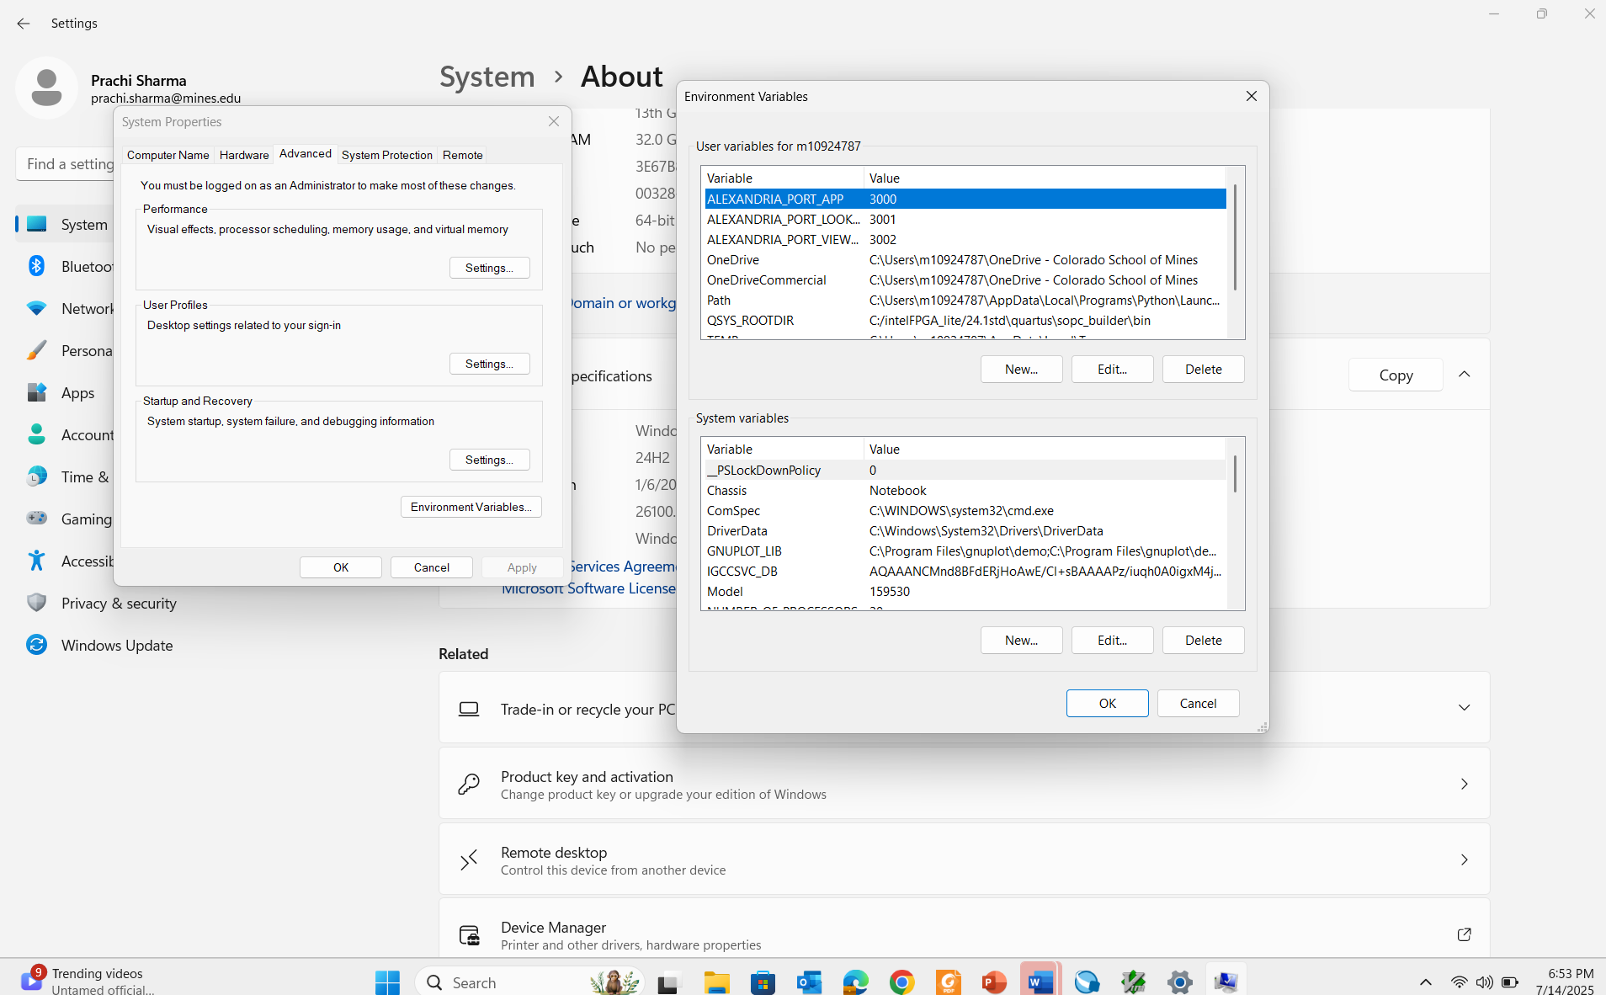
- Under System variables -> New -> Variable name as LM_LICENSE_FILE and then ‘Browse File’ to the location where you have saved the license file from step 15.
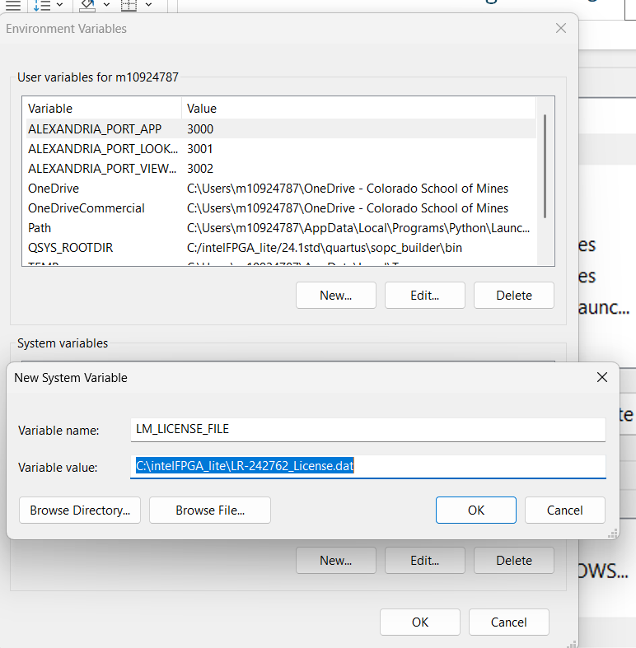

- Launch Quartus (if you don’t already have it open!). Go to Tools -> Options -> License Setup. This is similar to step 13b. You will now see the License File is recognized. Check the box against ‘Use LM_LICENSE_FILE variable’.
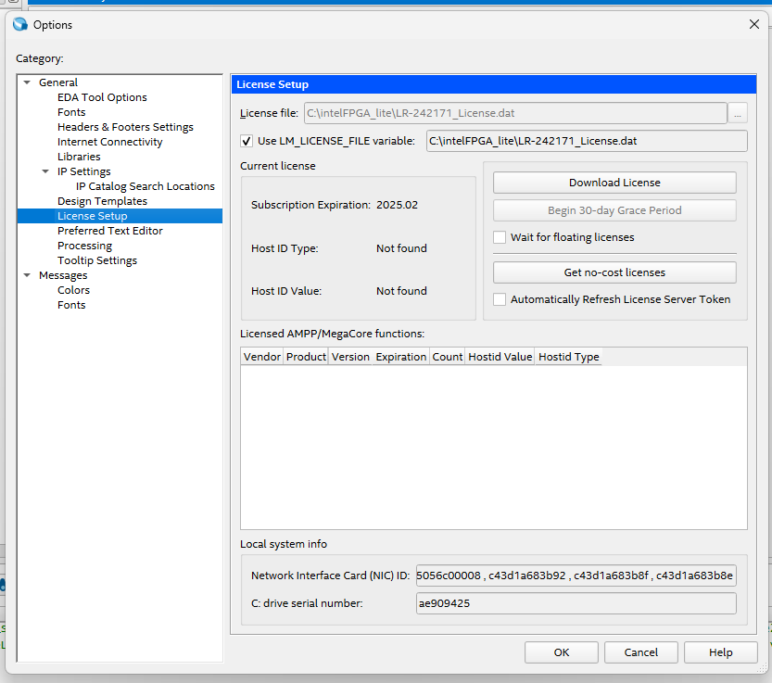
- Go to Tools -> Options -> EDA Tool Options -> Questa Intel FPGA (last one on the list). Check to ensure the path is same as in the snapshot below:
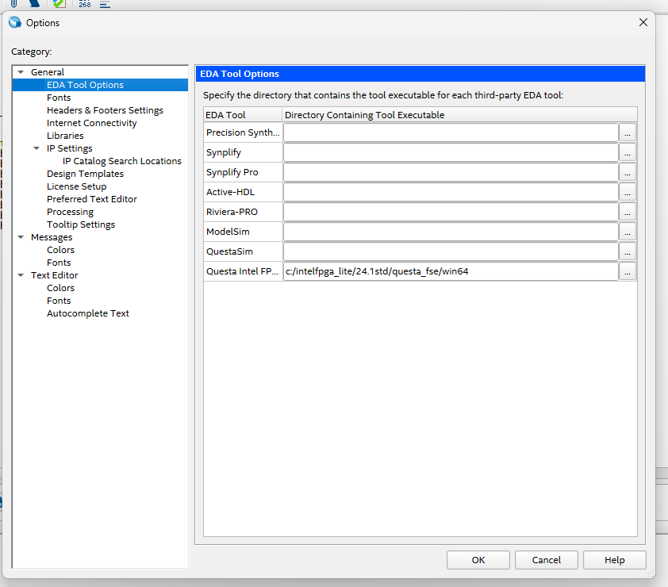
- Give yourself a pat on the back, you are all set to build your first project!

Source: Pinterest

